Miyazaki International College

Course Syllabus

Fall 2019

Course Title (Credits) | Reading 3 (2 credits)
Course Designation for TC | Discipline-related
Language Teacher
Instructor | Anne Howard
E-mail address | ahoward@sky.miyazaki-mic.ac.jp
Office/Ext | 304/3723
Office hours | Tuesday and Thursday 3-5 or by appointment

Course Description:
This course continues the goals of Reading 1 and 2 and aims to refine students’ ability to comprehend academic texts. The course focuses on developing reading skills in several ways. Intensive readings based on the theme of cultures of the English-speaking world will be used to improve reading comprehension strategies and for vocabulary building. Reading fluency will be developed using simplified timed readings in class and through extensive reading of graded materials both in class and for homework. Homework will consist of reading for meaning, for pleasure, and for the purpose of vocabulary building.

Course Objectives:
- To become more proficient in the following reading strategies: being a flexible reader, structural awareness, and synthesizing information
- To understand words from the first fivebands of the New General Service List when they are encountered in written text
- To improve understanding of the following grammar forms when encountered in written text: adjective clauses, reduced adverbial clauses, subordinators, conjunctive adverbs
- To use dictionaries to find information about definitions, parts of speech, and word collocations
- To increase reading fluency through timed reading practice and regular extensive reading
- To increase interest in reading for pleasure

Attainment Objectives for MEXT Teacher Certification:

- To be able to listen to English in various different genres and themes and to be able to understand the information and thinking to suit the purpose.

2) To be able to read English in various different genres and themes and to be able to understand the information and thinking to suit the purpose.
3) To be able to speak English (in conversation and presentation) to suit the purpose, scene and situation, etc., for various different themes.

5) To be able to execute language activities that integrate multiple themes.
Course Schedule:
Lesson | Topic | Content/Activities
1 | Course introduction | Course outline and objectives, syllabus, explanation of materials used in the class, expectations of students; timed reading
2 | Intensive reading 1a | Reading: Early British history, vocabulary & reading summaries  (H/W: vocab quiz)  TC objectives 1,2,3,5
3 | Reading/vocabulary | Timed reading / extensive reading / vocabulary: collocations  TC objectives 2, 5
4 | Intensive reading 1b | Reading: Early British history, reading summaries & comprehension (H/W reading comprehension)  TC objectives 1,2,3,5
5 | Reading/grammar | Timed reading / extensive reading / grammar: word parts  TC objectives 2, 5
6 | Intensive reading 2a | Reading: Dialects of English, Native peoples, vocabulary & reading summaries  (H/W: vocab quiz)  TC objectives 1,2,3,5
7 | Reading/vocabulary | Timed reading / extensive reading / vocabulary: adjective clauses  TC objectives 2, 5
8 | Intensive reading 2b | Reading: Dialects of English, reading summaries & comprehension (H/W reading comprehension)  TC objectives 1,2,3,5
9 | Reading/grammar | Timed reading / extensive reading / grammar: dictionary skills  TC objectives 2, 5
10 | Intensive reading 3a | Reading: Opposition to Britain in the colonies, vocabulary & reading summaries  (H/W: vocab quiz)  TC objectives 1,2,3,5
11 | Reading/vocabulary | Timed reading / extensive reading / vocabulary: subordinators  TC objectives 2, 5
12 | Intensive reading 3b | Reading: Opposition to Britain in the colonies, reading summaries & comprehension (H/W reading comprehension)  TC objectives 1,2,3,5
13 | Reading/grammar | Timed reading / extensive reading / vocabulary review test  TC objectives 2, 5
14 | Intensive reading 4a | Reading: Economies, World Englishes, vocabulary & reading summaries (H/W: vocab quiz)  TC objectives 1,2,3,5
15 | Reading/vocabulary | Timed reading / extensive reading / vocabulary: extended meanings  TC objectives 2, 5
16 | Intensive reading 4b | Reading: Economies, reading summaries & comprehension (H/W reading comprehension)  TC objectives 1,2,3,5
17 | Reading/grammar | Timed reading / extensive reading / multi-word units  TC objectives 2, 5
18 | Intensive reading 5a | Reading: Native peoples, vocabulary & reading summaries (H/W: vocab quiz) TC objectives 1,2,3,5
19 | Reading/vocabulary | Timed reading / extensive reading / vocabulary: conjunctive adverbs  TC objectives 2, 5
20 | Intensive reading 5b | Reading: Native peoples, reading summaries & comprehension (H/W reading comprehension)  TC objectives 1,2,3,5
21 | Reading/grammar | Timed reading / extensive reading / collocations  TC objectives 2, 5
22 | Intensive reading 6a | Reading: World Englishes, vocabulary & reading summaries (H/W: vocab quiz)  TC objectives 1,2,3,5
23 | Reading/vocabulary | Timed reading / extensive reading / vocabulary: reduced adverbial clauses  TC objectives 2, 5
24 | Intensive reading 6b | Reading: World Englishes, reading summaries & comprehension (H/W reading comprehension)  TC objectives 1,2,3,5
25 | Reading/vocabulary | Timed reading / extensive reading / vocabulary: word families  TC objectives 2, 5
26 | Intensive reading 7a | Reading: Politics, vocabulary & reading summaries  (H/W: vocab quiz)  TC objectives 1,2,3,5
27 | Reading/vocabulary | Timed reading / extensive reading / vocabulary: phrasal verbs  TC objectives 2, 5
28 | Intensive reading 7b | Reading: Politics, reading summaries & comprehension  (H/W reading comprehension)  TC objectives 1,2,3,5
29 | Intensive reading 8a | Reading: Multiculturalism, vocabulary & reading summaries  (H/W: vocab quiz)  TC objectives 1,2,3,5
30 | Intensive reading 8b | Reading: Multiculturalism, reading summaries & comprehension  (H/W reading comprehension)  TC objectives 1,2,3,5
Week 16 | Final Exam | Reading and vocabulary
Required Materials:
- A4 writing paper, pens, pencils
- Japanese-English, English Japanese dictionary
- Graded readers (online and from the Library)
- Handouts provided by teacher/ downloaded by students as necessary
- Textbook(s) and web-based software access

Course Policies (Attendance, etc.):
Attendance
Students will not get any points for attendance because it is expected that they will attend 100% of classes. However, students must attend over 60% of classes to receive a passing grade.

Academic Honesty
Students are not allowed to use translation software or Internet translation sites in this or any course at MIC. Although it is fine to work with classmates on homework assignments together, copying homework from classmates is unacceptable and will result in 0% on that assignment for both parties.

Assignment Submission
- Any assigned written work (not in the textbook or on the handouts) should submitted in typed format. Keeping backups is strongly recommended! Name, student number, teacher’s name, date, title, and page number(s) and exercise(s) of such assignment as appropriate should be written. Failure to do so may affect one’s grade.
- Any homework assignments written directly in the textbook or on the handouts must be completed on time to earn points. For assignments reviewed in class, late homework is unlikely to be accepted.

Class Preparation and Review:
- Students are expected to spend at least one hour reviewing and doing homework and one hour preparing for every hour of lesson time.
- “I was absent” is not an excuse for not completing assignments. If students miss a class, they should be sure to talk with your classmates first to find out what they have missed, then contact the teacher.
- If students do not understand anything at any time, it is their responsibility to ask questions. If they do not ask questions, the teacher will assume they understand everything.

Grades and Grading Standards:
Extensive Reading – 20%
In class, and sometimes as homework, we will work on intensive reading (see below). Extensive reading, however, refers to reading a large amount of longer, easier texts, focusing on the meaning. Although some class time will be used for extensive reading, most of it will be done on your own time, and you can decide what you read. You will be required to read a certain total number or words by the end of each month, and complete “quizzes” to prove that you have completed and understood the reading.

Timed Reading – 10%
During timed reading sessions in class, you will be required to read a short and relatively easy passage as quickly as you can while still understanding the main points. Your timed reading score will be based on later assignments in which you performed well.

Vocabulary using Praxis Ed – 10%
Continuing from Reading 1, you will be working almost daily on your vocabulary skills and critical reading skills using the online systems provided to you. The goal is to do 80 sessions on praxis ed throughout the semester.

Read Theory On-line Reading – 10%
The goal is to do 60 quizzes on Read Theory throughout the semester.

Intensive Reading & Course Activities – 30%
In class, and sometimes as homework, we will work on intensive reading, which is slow, careful reading of a small amount of difficult text, focusing on the language.
Assignments consist of reading, preparing for discussion, and completing text or handout exercises. We will go over homework in class. Therefore, if you do not complete the assignment(s), you will not only get 0 points, but you will also not be able to actively participate in class activities, in turn affecting your participation score as well. It is therefore essential that you complete the assignments to the best of your ability on time.
There will be activities and quizzes based on the main readings throughout the semester.

Final Exam – 20%
The final exam will take place during exam week. Information on the content of the exam will be given in class, but you can expect a reading comprehension test, and a vocabulary test. These will test your vocabulary knowledge and reading skills.

Note that for all online work, student efforts will be checked 4 times at regular intervals each semester:

Check 1: end of October
Check 2: end of November
Check 3: end of December
Check 4: last class of the semester

Details of goals for each check will be given in class.

Methods of Feedback:
In principle, work will be evaluated and returned within one week of submission. Feedback will be provided in the form of:
- Written comments on quizzes and assignments;
- Oral feedback both in class and during office hours;
- Model answers made available on Moodle and/or class handouts;
- Automatic feedback provided by online systems used in the course;
- Peer review and peer evaluation of oral paraphrases;
- Self-reflection on timed reading scores

Diploma Policy Standards Satisfied by Course Objectives:
Work completed in this course helps students achieve the following Diploma Policy objective(s):

1. Advanced thinking skills (comparison, analysis, synthesis, and evaluation) based on critical
thinking (critical and analytic thought)
2. The ability to understand and accept different cultures developed through acquisition of a broad knowledge and comparison of the cultures of Japan and other nations
3. The ability to identify and solve problems
4. Advanced communicative proficiency in both Japanese and English

Notes:
- You may be required to pay for some digital or printed material in this course.
- It is your responsibility to seek help if you need it. Please visit the teacher during office hours if you need study advice, and feel free to contact your teacher online.
- We will be using several online platforms in this course, such as the following:
- http://praxised.com/
- http://moodle.miyazaki-mic.ac.jp
- http://www.xreading.com
- http://www.readtheory.org
- http://www.socrative.com

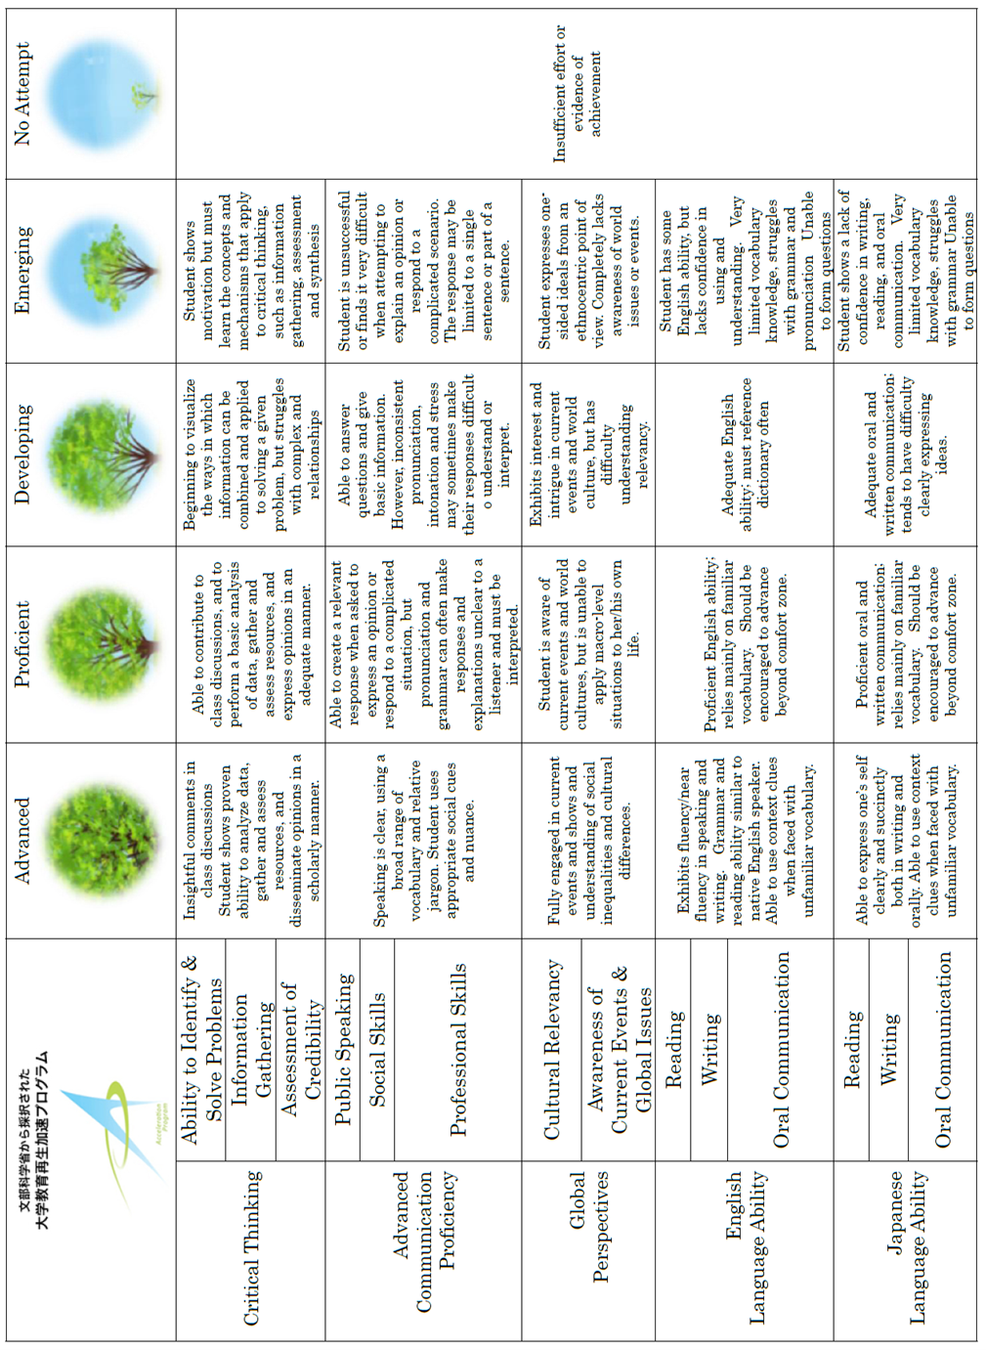

READING RUBRIC
Rating | Comprehension | Grammar | Vocabulary | Fluency
90% + | Can understand intensive readings at this level. This includes understanding of main ideas and details, structural awareness, and ability to make inferences. | Able to understand the grammar objectives for this level without difficulty. | Regularly achieves scores of 90% or more on vocabulary quizzes.  Very good understanding (80%) of NGSL vocabulary band. | Can read texts in timed reading activities at 200 words per minute with 80% comprehension.
80-89% | Can understand most elements of intensive readings at this level. This includes understanding of main ideas and details, structural awareness, and ability to make inferences. | Able to understand most of the grammar objectives for this level without difficulty in written text. Simple constructions can be understood easily, but complex constructions may be difficult. | Regularly achieves scores of 80-89% on vocabulary quizzes.  Good understanding (70%) of NGSL vocabulary band. | Can read texts in timed reading activities at 180 words per minute with 80% comprehension.  Or can read faster but with lower comprehension.
70-79% | Can understand some elements of intensive readings at this level. Can find main ideas and understand details, but structural awareness and ability to make inferences may be lacking. | Able to understand about half of the grammar objectives for this level without difficulty in written text.  Simple constructions can be understood, but complex constructions are difficult. | Regularly achieves scores of 70-79% on vocabulary quizzes.  Moderate understanding (60%) of NGSL vocabulary band. | Can read texts in timed reading activities at 160 words per minute with 80% comprehension.  Or can read faster but with lower comprehension.
60-69% | Can understand basic elements of intensive readings at this level. Can usually find main ideas and understand details, but structural awareness and ability to make inferences is lacking. | Able to understand about half of the grammar objectives for this level without difficulty in written text.  Simple constructions can usually be understood, but complex constructions are difficult. | Regularly achieves scores of 60-69% on vocabulary quizzes.  Limited understanding (50%) of NGSL vocabulary band. | Can read texts in timed reading activities at 140 words per minute with 80% comprehension.  Or can read faster but with lower comprehension.
less than 60% | Has difficulty understanding basic elements of intensive readings at this level. Can sometimes find main ideas and understand details, but structural awareness and ability to make inferences is lacking. | Has difficulty understanding the grammar objectives for this level in written text.  Simple constructions can sometimes be understood, but complex constructions are too difficult. | Regularly achieves scores of less than 60% on vocabulary quizzes.  Very limited understanding (<50%) of NGSL vocabulary band. | Reads texts in timed reading activities at less than 140 words per minute with 80% comprehension.  Or can read faster but with lower comprehension.

